COURSE TITLE: GENERAL PHYSICS

COURSE CODE: PHY 103

LECTURER: MR. FAREMI .A.A

Course outline: Hydrodynamics, Streamline, Bernoulli’s Equation and Continuity Equation.

**HYDRODYNAMICS**

Hydrodynamics can be referred to as a study of fluid’s flow. It is classified into compressible fluid flow and incompressible fluid flow.

**Compressible fluid flow**: compressible fluid flow can be defined as when the density of fluid is not constant or when the density of fluid does change during its motion.

**Incompressible fluid flow**: can be defined also as when the density of fluid does not change during its motion or the density of fluid remain constant.

**PROPERTIES OF HYDRODYNAMICS**

**Isentropic flow**: In fluid dynamics, an **isentropic flow** is a fluid flow that is both adiabatic and reversible. That is, no heat is added to the flow, and no energy transformations occur due to friction.

**Isothermal flow**: in **isothermal flow** the flow of fluid maintains constant temperature. The change in stagnation temperature of fluid flow occurs whenever there is change in velocity.

**Pressureless flow:** in fluid dynamics, a pressureless flow is a fluid flow with zero pressure.

**FLUID DYNAMIC**

Fluid dynamics is one of the most important aspects of physics. Fluid dynamics makes life possible because the air we breathe and the water we drink that constitutes our body mass is fluid. Motion of air keeps us comfortable in a warm room, and the air provides the oxygen we need to sustain life. It can be summarized that good health is as a function of proper motion of fluids.

**FLUID**

Fluid can be referred to as a substance that continually deform (flows) under an applied shear stress. It is also known as a substance that has no fixed shape and yield easily to external pressure, a gas or a liquid.

Recall, matter is divided into solids and fluids. Fluid is classified into liquids and gases.

An ideal fluid must be:

1. Incompressible-The density is constant.
2. Irrotational-The flow is smooth, no turbulence.
3. Non-viscous- There is no internal friction.
4. Steady flow- The velocity of the fluid at each point is constant in time.

**IMPORTANCE OF FLUIDS**

The importance of fluids are categorized into two

1. Physical and Natural Science
2. Technology

**FLUIDS IN THE PURE SCIENCE**

1. In atmospheric science, fluid made possible the analysis of climate change (global warming)
2. In geophysics, fluid is very important to the understanding of the formation of earthquakes, volcanoes as a result of thermally driven fluid motion.
3. Biological sciences, circulatory and respiratory system are made possible including cellular process by fluids.

**FLUIDS IN TECHNOLOGY**

1. Internal combustion that takes place in engines is made possible by fluids
2. Fluid makes possible chemical treatment, sewage transport and treatment in waste disposal.
3. Steam, gas and wind turbines and hydroelectric facilities for electric power generation are made possible by fluids.
4. Spraying and painting of automobiles, trucks etc, filling of containers e.g cans of soup, plastic bottles in manufacturing processes are possible by fluids.

**STREAMLINE**

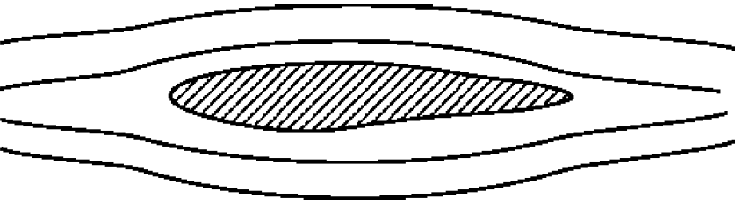

The line around the object is called a flow line. It is a path an individual fluid will pass. It is also called **streamline.**

NOTE: where streamline crowd or dense together the flow speed increases.

Some things to know about streamlines

* Because the fluid is moving in the same direction as the streamlines, fluid cannot cross a streamline.
* Streamlines cannot cross each other. If they were to cross this would indicate two different velocities at the same point. This is not physically possible.
* The above point implies that any particles of fluid starting on one streamline will stay on that same streamline throughout the flow.

**CHARACTERISTICS OF FLUID FLOW**

1. When there are low speed and low kinetic energy, there will be high pressure.
2. When there are high speed and high kinetic energy, there will be low pressure which is an indication of streamline close or crowd.

These terms describe the states which are used to classify fluid flow:

* Uniform flow: If the flow velocity is the same in magnitude and direction at every point in the fluid it is said to be uniform.
* Non-uniform: If at a given instant, the velocity is **not** the same at every point the flow is non-uniform.
* Steady: A steady flow is one in which the conditions (velocity, pressure and cross-section) may differ from point to point but DO NOT change with time.
* Unsteady: If at any point in the fluid, the conditions change with time, the flow is described as unsteady.

Combining the above we can classify any flow in to one of four types:

1. Steady uniform flow: Conditions do not change with position in the stream or with time. An example is the flow of water in a pipe of constant diameter at constant velocity.
2. Steady non-uniform flow: Conditions change from point to point in the stream but do not change with time. An example is flow in a tapering pipe with constant velocity at the inlet - velocity will change as you move along the length of the pipe toward the exit.
3. Unsteady uniform flow: At a given instant in time the conditions at every point are the same, but will change with time. An example is a pipe of constant diameter connected to a pump pumping at a constant rate which is then switched off.
4. Unsteady non-uniform flow: Every condition of the flow may change from point to point and with time at every point. For example waves in a channel.

**FLOW RATE**

Flow rate is classified into mass flow rate, Volume flow rate – Discharge and Discharge and mean velocity.

**Mass flow rate**:- mass flow rate enables us to determine the rate at which water flows along a pipe. This is made possible by catching all the outlet water from the pipe in a bucket over a fixed time period. Measuring the weight of the water in the bucket and dividing this by the time taken to collect this water gives a rate of accumulation of mass. This is known as the mass flow rate



Where Mfr= mass flow rate, Mfluid = mass of fluid in bucketAnd Tfluid= time taken to collect the fluid

**Volume flow rate – Discharge**: - volume flow rate is known as discharge which is denoted as Q. The discharge is the volume of fluid flowing per unit time. Multiplying this by the density of the fluid gives us the mass flow rate.

 Q = discharge, V = volume of fluid and T= time

**Discharge and mean velocity**:- the mean velocity of the water flowing along a pipe can be deduced provided the size of a pipe, and the discharge are known.

 um= means velocity, Q = discharge and A=cross section

**BERNOULLI’S PRINCIPLE**

An increase in the speed of fluid flow results in a decrease in the pressure or decrease in fluid’s potential energy.

**APPLICATIONS OF BERNOULLI’S PRINCIPLE**

1. Bernoulli’s principle can be used to calculate the lift force on an airfoil, provided the fluid flow in the vicinity of the foil is known. For example, if the air flowing past the top surface of an aircraft wing is moving faster than the air flowing past the bottom surface, then Bernoulli’s principle implies that the pressure on the surfaces of the wing will be lower above than below. This pressure difference results in an upwards lifting force.
2. This principle also explained the workability of engines’ carburetor and injectors. Carburetors and injectors are made with narrow throats which enable them to draw fuel. As the speed of air flowing increases, the pressure decreases.

**Q:** In a storm how does a house lose its roof?

**Ans:** *the streamline crowd around the top of the roof which result to increase in flow speed above the house and reduce pressure above roof to that inside the house, roof lifted off because of pressure difference*.

BERNOULLI’S EQUATION

Considering Euler equation, when gravity forces and viscosity are neglected

 (1)

Note that equation (1) valid for compressible flows. Integrate equation (1) as fluid move from points 1 to point 2 along a streamline

 (2)

 (3)

Equation (3) can be transformed to Bernoulli’s equation



 (4)

Equation (4) holds for Bernoulli’s equation which says that the total pressure along a streamline is constant. This expression is also valid for incompressible fluid flow.

Where ,  and 

Equation (4) can be transformed further when gravitational forces are considered.

Gravity force, 

Add gravity force to the both sides of equation (4)

 (5)

Equation (5) holds for Bernoulli’s equation under gravitational force

In Bernoulli’s equation, work done is equal to the algebraic sum of kinetic energy and potential energy.



CONTINUITY EQUATION

Continuity equation states that in a tube, the following must be true: Mass flowing in must be equal to mass flowing out.

 (6)

Equation (5) holds for mass conservation of fluid. It means fluid flowing into a tube equal to the fluid flowing out of it.

Recall density of fluid:

 (7)

 (8)

Substitute for mass in equation (6)

 (9)

Recall that 

 (10)

Since speed,  (11)

Substitute for in equation (10)





 (12)

Equation (12) holds for continuity equation.

PROBLEMS AND SOLUTIONS

Water is flowing in a fire hose with a velocity of 1.0m/s and a pressure of 200,000pa. At the nozzle, the pressure decreases to atmospheric pressure (101300pa), there is no change in height. Use Bernoulli’s equation to calculate the velocity of the water exiting the nozzle. (hint: density of water is  and gravity, g=)

Solution

Since there is no change in height, we apply Bernoulli’s equation without gravity



Make all the necessary substitutions and you get your as 14m/s

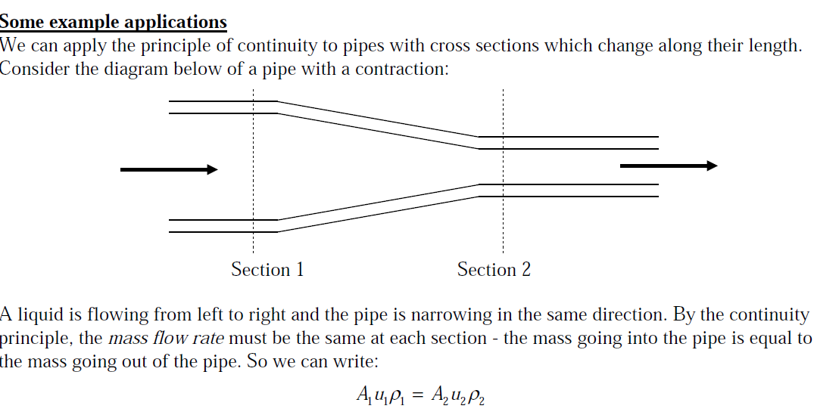 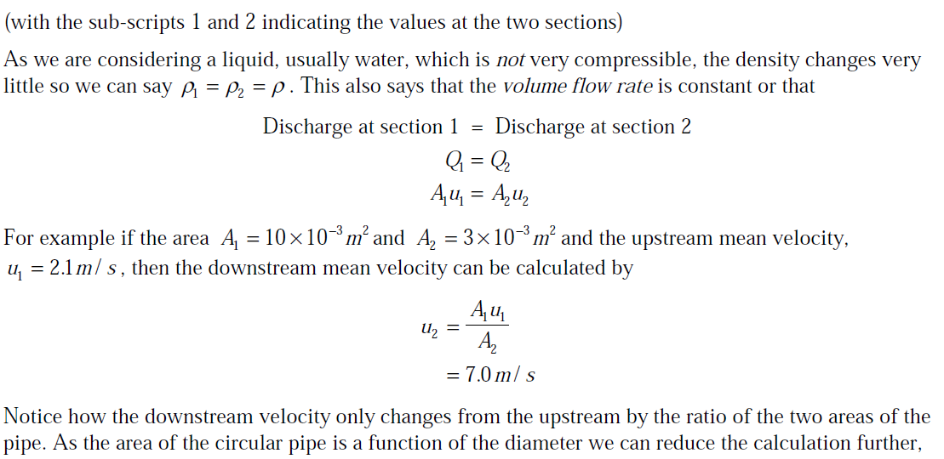

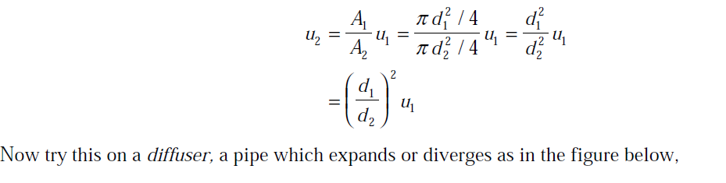

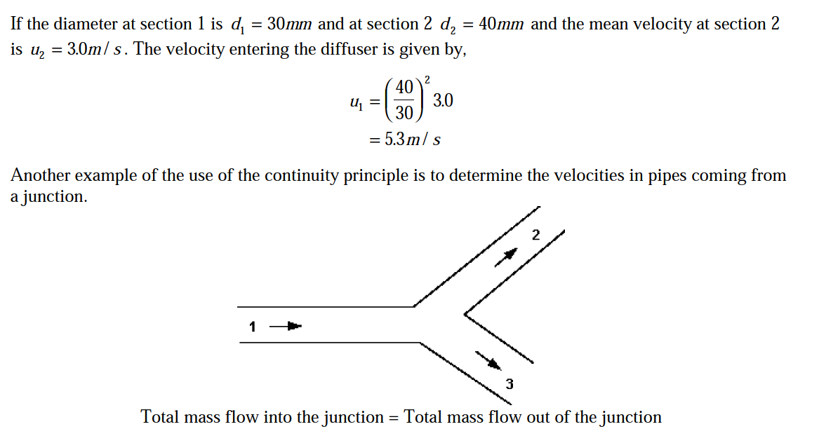

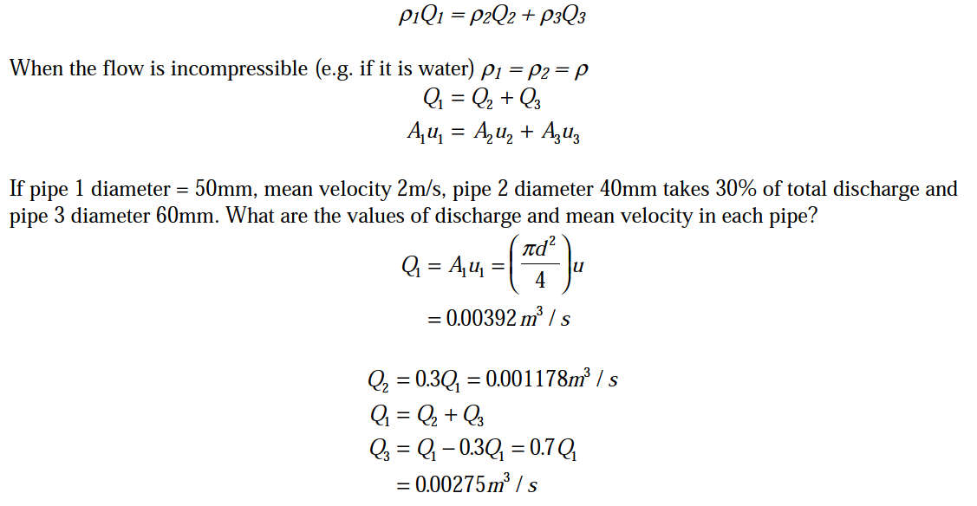

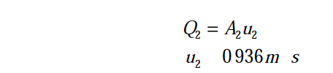

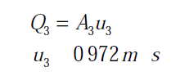

Questions

1. An empty bucket weighs 2.0kg. After 7 seconds of collecting water the bucket weighs 8.0kg. What is the mass flow rate?
2. Performing a similar calculation, if we know the mass flow is 1.7kg/s, how long will it take to fill a container with 8kg of fluid?
3. If the cross-section area, A, is1.2x10-3m2 and the discharge, Q is 24L/s, then the mean velocity of the fluid is?
4. Fluid is a substance that  
   (a) cannot be subjected to shear forces  
   (b) always expands until it fills any container  
   (c) has the same shear stress.at a point regardless of its motion  
   (d) cannot remain at rest under action of any shear force  
   (e) flows.  
   Ans: d
5. Fluid is a substance which offers no resistance to change of  
   (a) pressure   
   (b) flow  
   (c) shape   
   (d) volume  
   (e) temperature.  
   Ans: c
6. A fluid is said to be ideal, if it is  
   (a) incompressible  
   (b) inviscous  
   (c) viscous and incompressible  
   (d) inviscous and compressible  
   (e) inviscous and incompressible.  
   Ans: e
7. When the flow parameters at any given instant remain same at every point, then flow is said to be  
   (a) quasi static        
   (b) steady state  
   (c) laminar   
   (d) uniform  
   (e) static.  
   Ans: d
8. The continuity equation is connected with  
   (a) viscous/unviscous fluids  
   (b) compressibility of fluids  
   (c) conservation of mass  
   (d) steady/unsteady flow  
   (e) open channel/pipe flow.  
   Ans: c
9. An ideal flow of any fluid must satisfy  
   (a) Pascal law  
   (b) Newton's law of viscosity  
   (c) boundary layer theory  
   (d) continuity equation  
   (e) Bernoulli's theorem.  
   Ans: d
10. A streamline is defined as the line  
    (a) parallel to central axis flow  
    (b) parallel to outer surface of pipe  
    (c) of equal yelocity in a flow  
    (d) along which the pressure drop is uniform  
    (e) which occurs in all flows.  
    Ans: c
11. According to Bernoulli's equation for steady ideal fluid flow  
    (a) principle of conservation of mass holds  
    (b) velocity and pressure are inversely proportional  
    (c) total energy is constant throughout  
    (d) the energy is constant along a stream-line but may vary across streamlines  
    (e) none of the above.  
    Ans: d
12. The  equation of continuity holds good when the flow  
    (a) is steady  
    (b) is one dimensional  
    (c) velocity is uniform at all the cross sections  
    (d) all of the above  
    (e) none of the above.  
    Ans: d
13. Bernoulli equation deals with the law of conservation of  
    (a) mass   
    (b) momentum  
    (c) energy   
    (d) work  
    (e) force.  
    Ans: c